 | LIPHE HACKS  A series of resources to support your growth and development, brought to you by The Liphe Group  PRIORITISATION AND TIME MANAGEMENT – TWO SIDES OF THE SAME COIN

Wouldn’t it be wonderful if we all spent our time working on the things that really matter. The things that really make a difference, and doing it in a way which avoids burnout. Sounds amazing! In reality we scrabble around, jumping from one task to the next, multi-tasking work while sorting out the kids, working long hours and late nights. What we’re actually doing is spinning loads of plates and hoping that nothing falls.

In this Liphe Hack, we’re going to look at some techniques for managing your time (in a way that suits you) and helps you get the important stuff done. So when you climb into bed at night (at a sensible hour) you feel like you have achieved something.

So why two sides of the same coin? Prioritisation and Time Management - You can’t have one without the other. There is no point in knowing what your priorities are if you have no time to work on them. Equally there’s no point in making time for deep work if you then fritter it away on non-important tasks. You need both and you need them to work together. The key is being able to make time to spend on the actions which make a difference to achieving your goals and getting you to where you want to be.

A sensible word in your ear: As with all self-improvement techniques, there is no right or wrong answer. The intention is to provide some food for thought and ideas you can try. But that’s the important part – you have to try them and see what works for you. There are hundreds of ideas I could have covered but I’ve chosen only to include a few significant concepts which have worked for me and my clients. And remember - don’t just read this and put it to one-side – take some inspired action!

Step 1 – Understanding Time and how you spend it

Laura Vanderkam is a fascinating author on Time Management. Laura recommends that in order to know how to spend our time more effectively, we first have to know how we’re spending it. She recommends tracking your time for a week to see how much time you actually spend on various activities (spoiler alert – although it may seem like you work every waking minute, in reality it’s never actually as much as we think).

“The math is straightforward. There are 168 hours in a week. If you work 50, and sleep 8 per night (56 hours per week in total), that leaves 62 hours for other things…. The time is there to have what matters.” (Laura Vanderkam, Off the Clock)

In her book “Off the Clock”, Vanderkam conducted a research study entitled The Mosaic Project. In this research she looked at time logs from hundreds of people, especially women with careers and families and how they spend their time:

“What I really love about these time logs is that they really look like mosaics, arranged in patterns to allow for work, family time, personal time, sleep. No two women’s mosaics look the same, but when they are all taken together, they answer that perennial question of how does she do it? A life is lived in hours. Having a full life is possible if you place the tiles right.” (Laura Vanderkam, Off The Clock)

Take action: What does your mosaic look like? Can you see where you time is being spent well and where it is being wasted? Do you honestly know how much time is spent doom-scrolling on social media? Or what you could do with that time instead? Where are your non-negotiables that you won’t move or change? How can you rearrange the pieces of your mosaic to make time for the more important tasks?

Step 2 – Understanding when you work best

I’m going to pause here any talk about health and wellbeing, because this underpins everything else we want to achieve. In this context, I’m looking at understanding when you do your best work.

Our bodies have a circadian rhythm – a built-in smartwatch telling us when it’s time to feel sleepy and when it’s time to feel awake (see Resources for more info). It’s linked to a master clock in the brain (the hypothalamus) and regulates mental and physical systems, sleep, temperature and metabolism. By understanding how our bodies work on its 24 hour cycle, we can use this to influence the changes to our mosaic – put the difficult tasks when you know you work best, exercise when you know it works best for you, and move non-important tasks to when you know your concentration dips.

Take action: Are you an early bird or a night owl? Do you know what time of day you’re more productive? When are you better at solving more complicated problems? Do you have an afternoon lull where you get little done? Do you know how many hours of sleep you need? Take a few days to reflect on this and note how you feel throughout the day.

Step 3 – Defining your goals

Before we work out when you’ll complete your important tasks, you need to be absolutely clear on what you want to achieve and why.

There are loads of ways to define and write goals (eg SMART) but my tip is here is to step back and look at the bigger picture - it has to be something you connect with, at work or at home. You have to be able to step into the world of future you and see the benefit of achieving that goal. Will it make you healthier, happier, calmer? More confident or proud of what you have achieved? Will it have benefitted your customers? Your profits? Your families finances?

Take action: write down your top five goals (work and/or personal) and consider why you want to achieve them. What are the outcomes and benefits? Do that before you make an action plan. I would also recommend talking to others, such as your manager, partner, children or friends. Not only will they understand what’s important to you and help you achieve it, saying it out loud makes it more real and you will feel more accountable to achieve them - you can’t be let off the hook as easily!

Step 4 – Prioritising Your Tasks

For me, there’s only one method of prioritising your tasks and that’s the 4 Quadrants method, originally designed by Eisenhower and then developed by Stephen Covey. By categorising each task based on its urgency and importance, you can clearly and quickly prioritise what you need to get done first.

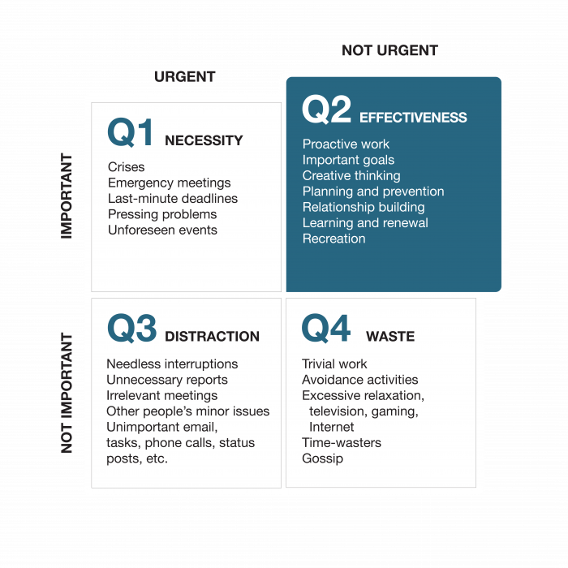
However an overlooked part of the model is our mindset. In his book “The 5 Choices to Extraordinary Productivity” Covey states that whether you are acting from a mindset of Urgency or Importance will profoundly affect your life.

If you have an Urgency Mindset, you will constantly be reacting to anything and everything which comes your way. Every message is answered immediately, every crisis gives you a dopamine hit and you become dependent on the rush and excitement. You’re the most important person in the team, right? Nothing gets sorted out without you? Hmm, is that really true or do you not let anyone else step in?

If you have an Importance Mindset, you have time to think, show your talents and create the future you want. Covey says that the most productive people stay in Quadrant 2 as much as possible, working on the tasks which are Important but Not Urgent.

Take action: Can you categorise the tasks in your To Do list into the four quadrants? Are there things in Q1 which have to be done first? Get them over with so you can move to Q2 and stay there as long as possible. My top tip if you use Microsoft Outlook is to set up custom categories (Q1 – Q4) and start to mark emails, To Dos and even meetings as the four quadrants. This will help you prioritise on the go, but it will also give you a deeper insight into how much time you spend in each mindset.

Step 5 – Using your time in a different way

So now we know – how we currently spend our time, what our big goals are, and what we want to work on to achieve them. All we have to do now is find the time!

The first thing I’m going to say here is that this is not about squeezing every minute and continuing to run around like a headless chicken. Shortening meetings from 30 mins to 25 mins will not actually make that much difference to what you can achieve. By understanding when you work best, you can move your mosaic around to clear some time for the things you need to do.

Here are my two top tips:

- Create time for Deep Work – this is a no brainer. To get anything done which needs your focus you need to remove any interruptions. Clear your diary for at least an hour. Say no to the 15 minute meeting that has popped in – move it elsewhere. Prioritise your work at the time you know you’ll work best.

- Batch your Tasks – give yourself an hour to do all the little tasks which take few minutes. This could include – answering emails, booking a train ticket, reaching out to a colleague, responding to a post on LinkedIn.

There’s a great metaphor for this by Stephen Covey about Rocks and Gravel. If you imagine you have a jar and the space inside is finite. Let’s say that’s our 168 hours in the week. You have some key priorities you need to get done (your big rocks) but you also have a miriad of tiny little things to get done too (your gravel). If you fill the jar with the gravel first, you can’t fit the big rocks in. However if you put the big rocks in the jar first, there’s still space for the gravel around the edges. If there isn’t room for all the gravel, it doesn’t matter much. (I’ve included the video link of Covey demonstrating this in the Resources.)

Take action: What are your big rocks for this week? Where in your diary this week can you free up at least an hour to work on them? Which meetings can you reschedule to achieve this? Write a list of all your smaller tasks (gravel) that you can do in your Batch Time – avoid the urge to just get them over with, hold them until that allotted time and get them done quickly then. It’s wonderful to tick so many things of your To Do list in one go! But remember to leave your Q4 tasks until last – it doesn’t matter if you don’t get them done – they’re the gravel that doesn’t fit in the jar.

I can’t move on from prioritisation without mentioning Brian Tracy’s book “Eat That Frog”. Consider that if the first thing you have to do each morning is to eat a live frog, then you can then go through the day knowing that you’ve got the worst thing already over with:

“Your ‘frog’ is your biggest, most important task, the one you are most likely to procrastinate on if you don’t do something about it now. It is also the one task that can have the greatest positive impact on your life and your results at the moment.” (Brian Tracy, Eat That Frog)

Take action: Develop the habit of deciding on your ‘frog’ every morning. Once you have your list of big rocks – choose your frog and eat that first!

“The ability to concentrate single-mindedly on your most important task, to do it well and to finish it completely, is the key to great success, achievement, respect, status and happiness in life.” (Brian Tracy, Eat That Frog)

Step 6 – Managing the expectations of others

Demands come at us from every angle – bosses, colleagues, clients, children, spouses. We don’t want to let any of them down. But equally we can’t be the best version of ourselves if we try and please everyone all the time. What’s important here is a conversation to manage expectations, to explain what you can do really well for them, and where you have to push back a timescale or politely say no. Using the four quadrants will really help you here – your big rocks will be in Q2 (or maybe Q1) and the gravel will be in Q4 (and maybe Q3).

And remember earlier when I said to talk to others about your goals? If they already understand what you’re trying to achieve then this will be an easier conversation.

I want to make a shout-out here to anyone who works part-time. Having worked part-time for over 10 years I know how important it is to try and prove that you can deliver as much if not better than others, even those who are working more hours. It’s taken me a long time to realise that’s pretty impossible, and I would encourage you to use the techniques above to really think about what you can place in a smaller jar.

And also, please call it out if you’re being asked to do a full-time job in part-time hours. Talk to your manager about what you can do in the time you have available.

For anyone in a Job Share partnership, talk to your partner about what you can deliver. Can you split tasks based on your strengths or development needs? Ask them if they need help to move the tiles in their own mosaic. A partnership needs to be give and take – work together to agree your big rocks and gravel.

For me, an important part of working part-time has been my focus on stakeholder management. Keep them updated on your progress, let them know when you’re available and who can help (if they really need it) while you’re out of the office.

When you come across something that you really can’t take on (or don’t think you should), here’s a technique to say a Positive No:
- Start with a Positive (eg thank you for thinking of me or this project sounds interesting)
- Tell them your priorities (eg right now I have the following workload or in our previous meeting we prioritised this other work)
- Then state why you can’t take it on (eg so I can’t take it on right now or are you ok if I pause my other work to pick this up)
- Offer an alternative (eg Kelly is new to the team and looking to meet new colleagues so it might be good for her or can it wait until tomorrow/next week when I have time to dedicate to it)
I know it’s not easy to have this conversation but if you focus on your priorities and what’s important, it gets easier to sift out the gravel.

Take action: Who are the important stakeholders you need to talk with? What’s the conversation you need to have? Think about what the other person needs and what you can deliver for them, even if it’s not everything they hoped for, and explain why. These stakeholders may be at work or at home – don’t rule out having a conversation with your kids if you need to.

Step 7 – Reflect and Evolve

There is no perfect system but only by trying will you find out what works for you. Give it a go, adapt and evolve the process if you think you have a way which works better for you. Invest the time up front to think about your goals and understand where you are really spending your time.

“Time is finite, so we must make smart choices about it. But time is also abundant: there is enough for anything that truly matters.” (Laura Vanderkam, Off the Clock)

Thanks for using your time to read this – I hope you found it useful. Remember to visit www.theliphegroup.com for more resources or to talk to us about how 121 coaching can accelerate your development. Speak soon, Kelly

This Liphe Hack was originally published by The Life Coach Directory on 31st July 2023
https://www.lifecoach-directory.org.uk/memberarticles/prioritisation-and-time-management-two-sides-of-the-same-coin
References and Additional Resources

Laura Vanderkam (includes a Time Tracking tool)
https://lauravanderkam.com/

Stephen Covey:
https://resources.franklincovey.com/the-5-choices-to-extraordinary-productivity
The Four Quadrants:
https://www.franklincovey.com/habit-3/
https://resources.franklincovey.com/the-5-choices-to-extraordinary-productivity/choice-1-act-on-the-important-dont-react-to-the-urgent
Rocks and Gravel in the Jar:
https://resources.franklincovey.com/the-8th-habit/big-rocks-stephen-r-covey

Eisenhower Matrix:
https://www.eisenhower.me/eisenhower-matrix/

Eat That Frog
https://www.briantracy.com/blog/time-management/the-truth-about-frogs/

Circadian Rhythm:
https://www.sleepcycle.com/circadian-rhythm/circadian-rhythm-is-the-smarter-smart-watch/

